
Jurnal EVOLUSI

Please cite this article as:

TITLE IS SUGGESTED FOR A MAXIMUM LENGTH FOR 12 WORDS

Author1*(a), Author2 (b)
Corresponding author*

(a)Affiliation, Author1@email.com
(b)Affiliation, Author2@email.com
DOI:
Received xx April 2024, Accepted xx April 2024, Available online xx May 2024

ABSTRACT
ARTICLE INFO

This document represents the required format for manuscript preparation for publication. By having a standardized format of submission, the editor and reviewers can make the assessment process with clarity. This template assists the author in familiarizing with the submission format and understanding the function of each section. On writing the actual abstract, it should be between 200 - 250 words in a single paragraph. It should be a concise summary that clearly outlines the paper’s rationale, methodology, findings, and contribution. The body text should be presented with justified alignment
Keywords:
Keyword 1,
Keyword 2,
Keyword 3,
Keyword 4,
Keyword 5

- INTRODUCTION (HEADING 1)
HEADING 1 (Align left, UPPERCASE. Bold, Times New Roman 12)
This template is constructed to assist authors in presenting their work so that it will be easy to be reviewed by the reviewers. Having a standard template will also assist in the eventual publication process should the paper is accepted. Submitting an article that is easier to be read by the reviewer will assist in expediting the review process.
This template was designed such that the author can substitute each section with one’s work accordingly and expand it as necessary. It includes samples of referencing and type formatting which is expected when submitting a manuscript in MS Word, which is the only acceptable format. The manuscript must not exceed 10,000 words excluding references and appendices. The manuscript also should meet the similarity index for less than 30%. The body text should be presented in a single paragraph with justified alignment.
- LITERATURE REVIEW (HEADING 1)

Dependent Variable (Heading 2)
Heading 2 (Align left, Capitalize Each Word, Bold, Times New Roman 12)
Submitted an article should be structured in a way that follows a suitable journal publication style. The paper should be segmented with appropriate headings such as the following flow: Abstract, Introduction, Methodology, Results, Discussion/Conclusion, and References. However, the author may include other headings as deemed necessary, such as Literature Review and Acknowledgement. The body text should be presented in a single paragraph with justified alignment.
Subheading (Align left, Capitalize Each Word, Times New Roman 11)
Subheadings may be inserted to improve the structure of the paper. This paragraph is an example of how a sub-heading. If required, a further hierarchical breakdown can utilize the subsection or bullet points. The body text should be presented in a single paragraph with justified alignment.
Subsections (Align left, Sentence case, Bold, Times New Roman 10)
This section is to illustrate the format in the subsection. The text should be represented in a single column with justified alignment. The body text should be presented with justified alignment.
- METHODOLOGY
FIGURES AND TABLES
Figures and tables are to be embedded in the main text body. They should not have cosmetic enhancements such as a shadow frame. One blank line separates the figure or table with the following text.

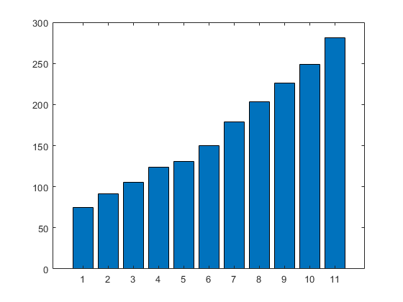
Figure 1. Each figure/image must be explained by a legend at the bottom using the same format as body text.
Table 1. Each table must be preceded with a label placed with the sequence number and title using the same format as body text.
TYPE | CASE | FONT | SIZE | FORMAT | ALIGNMENT
HEADING | UPPER | TIMES NEW ROMAN | 12 | BOLD | CENTER
SUBHEADING | UPPER | TIMES NEW ROMAN | 12 | NORMAL | CENTRE
Subsection | Sentence | TIMES NEW ROMAN | 12 | NORMAL | CENTRE

- FINDINGS AND DISCUSSION
Write here.
- CONCLUSION
Write here.

REFERENCES
American Psychological Association. (2010). Mastering APA style: Student's workbook and training guide (6th ed.). Washington, DC: American Psychological Association.

